The Soar 8 Tutorial

John E. Laird

University of Michigan

June 8, 2005

This tutorial is the culmination of work by many people. Eaters was developed by Randy Jones and then refined and updated by Scott Wallace. Mazin Assanie developed TankSoar based on Tag-Soar, which was originally developed by Mike van Lent. Soar 8 is based changes to Soar 7 suggested by Bob Wray’s thesis work, but also includes changes to the decision cycle suggested by Randy Jones, and refined by Bob Wray, Karen Coulter, and Mike van Lent. Karen Coulter brought all of the pieces of Soar 7 and Soar 8 together and is responsible for the final integration and release of the Soar 8 code. Brad Jones originally developed VisualSoar, which was extended by Brian Harleton and Andrew Nuxoll. Thanks to Alex Roper for updating the figures to the TSDebugger and Taylor Lafrinere for updating figures to the Java debugger and including information on VisualSoar. New Java versions of Eaters and TankSoar were developed by John Duchi.
Introduction

This is a guide for learning to create software agents in Soar, version 8. It assumes no prior knowledge of Soar or computer programming.

The goals of this document are:
- Introduce you to the basic operating principles of Soar.
- Teach you how to run Soar programs and understand what they do.
- Teach you how to write your own Soar programs.

This is about the nuts and bolts of writing Soar programs, but not about the theory behind Soar. For that, you should read Chapter 3 of the Soar Manual.

This tutorial takes the form of a sequence of lessons. Each lesson introduces concepts one by one and gives you a chance to use them by creating Soar agents. Each lesson builds on the previous ones, so it is important to go through them in order. To make the best use of this tutorial, we recommend that you read the tutorial, do the exercises, run the programs, and write your own Soar agents. The programs are available as part of the standard Soar installation. Please use the most recent version. Although the tutorial is long, you should be able to work through it quickly.

What is Soar? We call Soar a unified architecture for developing intelligent systems. That is, Soar provides the fixed computational structures in which knowledge can be encoded and used to produce action in pursuit of goals. In many ways, it is like a programming language, albeit a specialized one. It differs from other programming languages in that it has embedded in it a specific theory of the appropriate primitives underlying reasoning, learning, planning, and other capabilities that we hypothesize are necessary for intelligent behavior. Soar is not an attempt to create a general purpose programming language. You will undoubtedly discover that some computations are difficult or awkward to do in Soar (such as complex math) and they are more appropriately encoded in a programming language such as C, C++, or Java. Our hypothesis is that Soar is appropriate for building autonomous agents that use large bodies of knowledge to generate action in pursuit of goals.

This tutorial is specific to Soar 8, which has significant changes from earlier versions of Soar. These changes improve Soar’s ability to maintain the consistency of its reasoning while interacting with dynamic environments.

The tutorial comes in six parts. Part I introduces Soar using a simple puzzle task called the Water Jug to introduce the basic concepts of Soar. This is the classic type of toy problem that people in AI now rail against as being completely unrepresentative of real world problems. Maybe true, but it is simple and easy to understand. After working through Part I, you should be able to write simple Soar programs. Part II uses a Pacman like game called Eaters to introduce interaction with external environments. Part III uses a grid-based tank game called Tank-Soar and introduces Soar’s subgoaling mechanism as it is used for task decomposition. Part IV uses Missionaries and Cannibals problems to further explore internal problem solving and search. Part V uses Missionaries and Cannibals along with the Water Jug to introduce look-ahead planning and learning. Finally, Part VI gives an overview of creating a more complex Soar system for playing Quake.

Soar has its own editor, called VisualSoar, which is highly recommended for use in developing Soar programs. VisualSoar is part of the standard installation and is also available from the Soar homepage.

NOTE: This tutorial is for Soar 8.6 and beyond. In 8.6.1, TankSoar is not included in the release because of technical difficulties. We are actively working to port it to 8.6, but for now it only runs in Soar 8.5. Thus, you may want to run 8.5 in order to work through those parts of the tutorial until they run in 8.6. Release 8.5 has a different debugger, but otherwise is compatible with 8.6.
Part I: Simple Soar Programs
Throughout this tutorial, you will be writing and running Soar programs for simple tasks. In this part, you will be writing simple programs that do not use Soar subgoaling or chunking mechanisms.

1. Installing Soar

Before reading further in the tutorial, you should install Soar and its associated software on your computer so that you can run the examples and exercises. Using your favorite browser, visit the Soar Getting Started page: http://sitemaker.umich.edu/soar/getting_started. Follow the directions on that page for installation. We recommend installing all of the Soar software so that you have a directory with the most recent release of Soar, the Eaters game, the TankSoar game, and VisualSoar.

2. Building a Simple Soar Agent Using Rules

All of the knowledge in a Soar agent is represented as if-then rules. In Soar, rules are called productions, and we will use the terms interchangeably. Rules are used to select and apply things called operators, and much of this tutorial will be describing how rules and operators fit together. But before we get to operators, we are going to learn about writing rules for a very simple agent – one that just prints “Hello World.” Before we dive into rules, you will need to start up Soar so that we can run the programs you write.

2.1 Creating a Soar Agent and Using the Soar Debugger
To start Soar, double click (or whatever is appropriate on your platform) on the Start Soar Debugger (Java) file in the folder where you installed Soar, or in Windows, click the Start button, select Programs, find Soar 8.6.0 and click Start Soar Debugger. After Soar has started, you will have a new window on your screen. This window is the Soar Debugger, which is shown below. This program will be used to run all of your Soar programs.

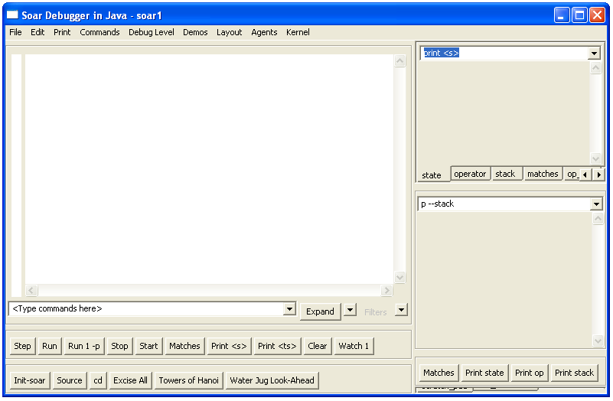
Interaction window

The large window to the left is called the Interaction window (above). During Soar execution, all debugging information and print statements will be displayed in the Interaction window. The windows on the right display values that you will find useful later.
When the Soar Debugger starts, a default agent entitled ‘soar1’ is created. The name of the agent can be seen on the title bar. To create a new agent (which you should do at this time to get experience with creating new agents), click Agents on the menu bar. To open a new agent in the current window select Create Agent – Same Window, to do so in a new window click Create Agent – New Window. For the purpose of this tutorial, open a new agent in a new window.
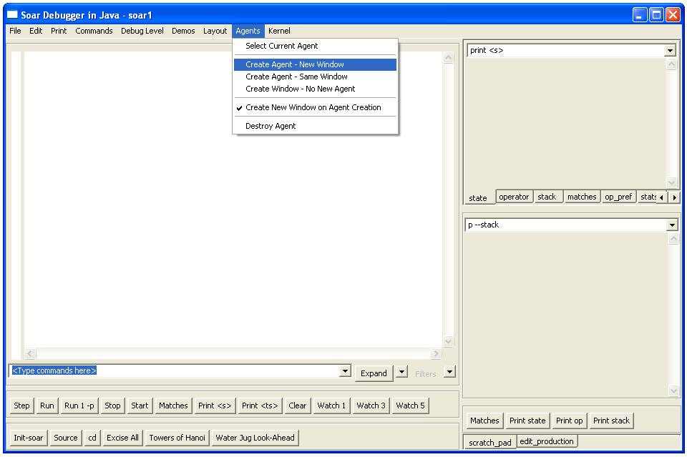

A dialog box entitled Create Agent will pop-up. In the text box type “hello-world” and click OK.
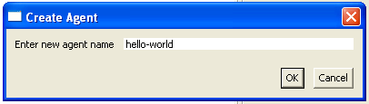
Click to create your agent

This action creates a new Soar Debugger window that looks much like the one already open. Right now the only difference in appearance between the two windows is their respective titles ‘soar1’ and ‘hello-world.’ Each of these windows represents different Soar Agents. Make sure that the debugger with hello-world as the title is active. The bottom of the window contains buttons for single stepping, running, or stopping an agent. When it is time to run your Soar programs, commands can either be entered by typing them into the command box, or by clicking the buttons
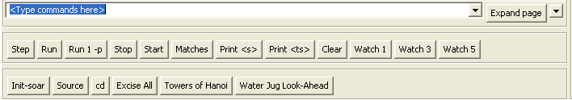

2.2 Hello-World Rule: English
The first Soar agent we will examine prints “Hello World”. In general, an operator should perform this type of activity, but in order to ease you slowly into Soar, we start with a single rule. Below is a simple rule written in English.
hello-world:
If I exist, then write “Hello World” and halt.
Soar cannot directly interpret English, so you must write rules in Soar’s very stylized and precise language. A major component of the rest of this tutorial is teaching you that language.

Soar works by testing the ”if” parts of rules (“If I exist”). These ”if” parts are called conditions. If all of the conditions of a rule are true in the current situation, the ”then” parts, or actions, of the rule (“write ‘Hello World’ and halt”) are executed, which usually involves making changes to working memory, which holds all of the dynamic data structures in a Soar program. Executing the actions of a rule is called firing the rule. To determine if the conditions are true, Soar compares them to data structures in working memory. Working memory defines the current situation, which for an agent consists of its perception of its world, results of intermediate calculations, active goals, and operators.

The figure below shows a high level view of Soar. On the right are all of the underlying architectural processes that select operators, create states, learn new rules, etc. These are all written in C and you will not be changing them at all (so don’t worry if you don’t know C). In the upper center is the rule memory, which contains all of the rules. Rules encode the long-term knowledge in Soar and adding them is the way Soar is programmed – you do not change the way Soar creates states or learns, but you create rules. Working memory is where short-term information is stored and your rules will create and test structures in working memory. In contrast to C or Java, which have programs that are executed sequentially, Soar has rules that are matched and executed in parallel. C and Java have data structures, variables, etc. while Soar has working memory. While these other languages have a combination of local and global data, Soar has no local data – everything in working memory is global. Working memory consists of a graph structure of individual elements. The elements are created by rules as well as from sensors (not shown in the diagram), and the Soar architecture creates a limited set of working memory elements (the core part of states) automatically. Working memory is matched against rule memory to determine which rules will fire. When rules fire, they can make changes to working memory, as well as performing simple actions such as printing messages in the interaction window.

Working Memory

Rule Memory
Decision
Making

State
Creation

Learning

…

2.3 Loading and Running Hello-World
Before going through the nitty-gritty of Soar syntax, let’s see an example of Soar executing the hello-world rule. In order to execute the hello-world rule, it must be loaded from a file into Soar’s rule memory. You can load in the rules from a file via the Interaction window by either clicking the “source” button or by using the File menu at the top left (you can also type the source command directly into the interaction window, but for that you need to know the path to the file).

To use the File menu, click on the toolbar as shown in the figure below.

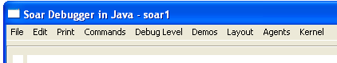
Click on this menu

The following menu will pop up; select Load source file…

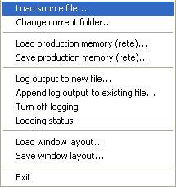

Alternatively, click on the “source” button at the bottom of the interaction window. In both cases, a menu to select the file will pop up, such as below (your menu might have a different set of files available). You can navigate in this menu to get to the correct directory (<soardir>/soar-library/demos/) and then select the file you want to load (hello-world-rule.soar).

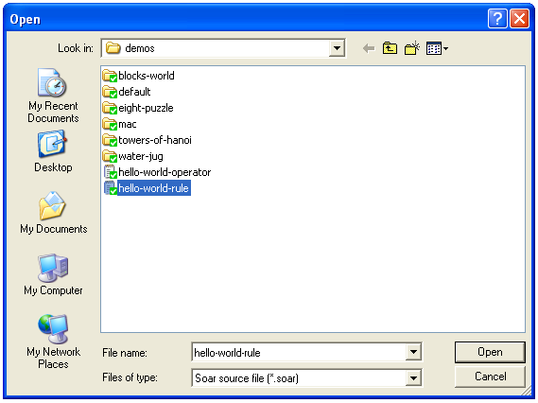
When rules are loaded into Soar, an “*” is printed for each rule in the trace. When the file has loaded, you will see the word “source” followed by the location of the file in the interaction window,

At this point you can type run, or click on the run button in the bottom left of the interaction window. The first thing that happens is that Soar automatically creates the initial state, S1 (but this is not shown in the interaction window, but is shown in the window on the right where the state S1 is printed). All of working memory is organized as states, so even before any rules fire, a state is created. After the state is created the rule matches (details explained later) and it fires, performing its actions, printing “Hello World” and then halting.

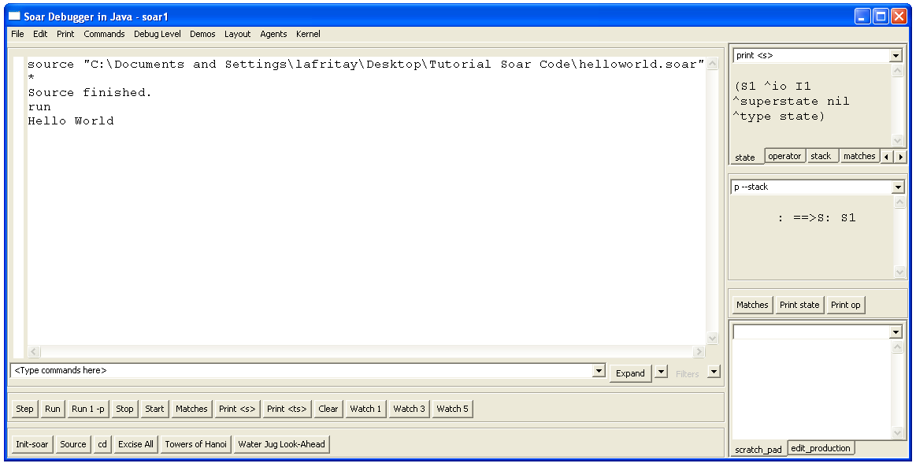
Soar always automatically creates a state (S1) for all data.
“Hello World” printed out by rule followed by halt.
Start executing Soar by typing run in the command window or clicking on the run button.
Trace of run command being executed.
2.4 Hello-World Rule: Soar
As stated earlier, Soar has a stylized and precise language for writing rules. Here is the Soar rule for hello-world.
sp stands for “Soar production” and starts every rule.
The “{“ starts body of a rule.
The name of the rule immediately follows the “{“. The name can include letters, numbers, “-“, and “*”.

These are the then parts of the rule (actions).
sp {hello-world
This is the if part of the rule (condition).
(state <s> ^type state)
-->
(write |Hello World|)
The --> separates the if and then parts of the rule.
The “}” ends the rule.
(halt)}

Every rule starts with the symbol “sp”, which stands for “Soar production.” The remainder of the rule body is enclosed in curly braces: “{“ and “}”. The body consists of the rule name, followed by one or more conditions (the “if” part), then the symbol “-->“, and then one or more actions (the “then” part). Below is a template for rules:
sp {rule*name
(condition)
(condition)
… means additional conditions can follow.
…
-->
(action)
(action)
… means additional actions can follow.
…}
The name of the rule can be any arbitrary combination of letters, numbers, dashes (“-“), and asterisks (“*”). The one exception is that a name cannot be a single letter followed by a number such as S1 or O45. Soar reserves those names for its own purposes. The specific name is irrelevant to the operation of the rule, but you should always pick a name that is meaningful. Following the name, there must be at least one condition. A condition tests for the existence (or absence) of data in working memory. If all of the conditions match, then the rule will fire and all of the actions are performed. Most actions create new working memory elements or remove existing working memory elements. Some actions create preferences for selecting operators (more on that later), while others perform functions such as writing text to the screen or halting as in hello-world.

In the next several sections we will explore the structure of conditions and actions and explain what all of the special symbols, such as <s> and ^type, mean. Before doing that, we need to first look at the structure of working memory in more detail.

2.5 Working Memory
Working memory contains all of a Soar agent’s dynamic information about its world and its internal reasoning. It contains sensor data, intermediate calculations, current operators and goals. In Soar, all of working memory is organized as graph structures in states. Thus, every working memory element is connected directly or indirectly to a state symbol. For the first agents you will build, there will be a single state. Below is a simple example of what the structure of working memory might be like if the agent were representing that there were two blocks, one on top of the other, which is then on a table as shown in the figure below.
Below is a graphic picture of the working memory structures that Soar creates automatically for every agent – so although not shown in the above figure, S1 would have these additional structures.
B
A
^table
^block
^block
S1
State identifier
Attribute
Value
^ontop
^ontop
^name
A
blue
block
B
yellow
block
Table
gray
table
^name
^name
^color
^color
^color
^type
^type
^type
B1
B2
T1
^type
^io
^superstate
state
nil
^input-link
^output-link
S1
I1
I2
I3
State identifier
Attributes
Value
As a graph, there are nodes (or vertices) and links (or edges). The nodes, such as S1, B1, B2, A, and blue, are connected by links, such as block, table, name, color, and superstate. Soar has two kinds of nodes: identifiers and constants. The nodes that can have links emanating from them (they are non-terminal nodes), such as S1 and B1, are called identifiers, while the others (they are terminal nodes), such as state, blue, block, and nil, are called constants.

In the example above, S1 is the identifier for the state. All of the identifiers symbols are created automatically by Soar and consist of a single letter followed by a number. Although I2 and I3 in the lower figure do not have any links emanating from them, they are identifiers and can have additional substructures added later. In contrast, the symbol state is not an identifier and cannot have links emanating from it. The links are called attributes in Soar and are prefaced by a “^”. Only identifiers have attributes. In the bottom figure, S1 has three attributes: superstate, io, and type. I1 has two: output-link and input-link.

Working memory is actually built of individual elements which are triples of an identifier, an attribute, and value, and where the value is that node pointed to by the attribute. The value can be either a constant or an identifier. In the example above, the symbols nil, I1, state, I2, and I3 are all values. It is these triples that you add and delete when writing Soar programs.

There are five working memory elements in the figure above:
S1 ^superstate nil
S1 ^io I1
S1 ^type state
I1 ^output-link I2
I1 ^input-link I3
This is the minimal contents of working memory, and as your programs get larger and more complex, they will manipulate many more working memory elements.

A collection of working memory elements that share the same first identifier is called an object. For example, the three working memory elements that have S1 as their identifier are all part of the state object. The working memory elements that make up an object are called augmentations. Although we call them objects, they consist of the individual working memory elements that share the same identifier. Objects are usually written as a list of the augmentations surrounded by parentheses. The first item in the list is the identifier that is shared by all of the augmentations, followed by the pairs of attributes and values for each augmentation. The objects for the above working memory elements are:
(S1 ^io I1 ^superstate nil ^type state)
(I1 ^input-link I3 ^output-link I2)

An individual augmentation can also be written in this form:
(S1 ^type state)

A working memory object usually represents something about the world, such as a block, a wall, a piece of food, or a cell on the board. The individual augmentations represent properties (such as color, size, or weight), or relations with other objects (such as on top of, behind, or inside).

Soar can be used for many different tasks, and for each different task, working memory will contain descriptions of the task objects. The working memory elements for the blocks would be as follows:

B
A
(s1 ^block b1 ^block b2 ^table t1)
(b1 ^color blue ^name A ^ontop b2 ^type block)
(b2 ^color yellow ^name B ^ontop t1 ^type block)
(t1 ^color gray ^name Table ^type table)

Working memory usually also contains objects that are only conceptual things and do not have an identifiable physical existence, such as state s1, which organizes other objects, relations, and properties. The exact representation of objects is up to you, the designer of a Soar program.

Soar does not require any declarations of the possible attributes and constants. In fact, some Soar programs generate new attributes and constant values as they execute. The Soar editing and development tool, VisualSoar, does require declarations for the structure of working memory elements, and those declarations are used to check for errors in your rules but they are not used by Soar when it is executing a program.

2.6 Hello-World Rule: Soar Details
You now know enough to return to the first example rule. The original English version included the test
“If I exist”
Remember that when every Soar agent is created, it has (s1 ^type state) in working memory, which signifies in someway that the agent does exist. Thus, you can test for the presence of that structure in working memory to determine if the agent exists. The obvious condition to write would be (s1 ^type state). However, s1 is just an arbitrary symbol and might not be the identifier of that state every time the agent is run. Thus, we need a test that there is an identifier, but without testing a specific value. That is exactly what a variable does – it matches any symbol in working memory with the only constraint being that all occurrences of the same variable in a rule match the same symbol. A variable can match an identifier, an attribute, or a value, depending on its position in a condition – if it is first in a condition it will match the identifier, second the attribute, and third the value. A variable is a symbol surrounded by “<” and “>”, such as <s>. The exact symbol used in the variable (such as “s”) is irrelevant but should be picked to be meaningful to you.

Putting these pieces together gives: (<s> ^type state). That is almost correct, but in Soar, every rule must start by matching a structure in a state, and to remind you of this, the first condition of every rule must start with the word “state”.
The first condition always starts with “state”
A variable that matches any identifier in this position
sp {hello-world
This condition tests that there is a state
(state <s> ^type state)
Vertical bars surround text
-->
Prints the following items to the Interaction Window
(write |Hello World|)
Halts the agent
(halt)}

The original text for the rule’s actions was: then write “Hello World” and halt.
The rule’s first action prints “Hello World” in the Interaction window. Vertical bars, “|”, mark constants with special characters. These constants can contain any characters, which allows you to print spaces, upper and lower-case letters. The second action is a special command in Soar that halts the agent. From this simple example, you should be able to write your own rules that print out different messages for Soar.

If you wish to try this out yourself, you have two choices. The first is to use VisualSoar. VisualSoar is the Soar development environment and it lets you develop and manage Soar programs. It has its own documentation and tutorial and can be found at the Soar web pages. Also, the Water-Jug problem that is presented later in this tutorial contains an explanation of how to use VisualSoar. Although it will initially slow you down to learn VisualSoar, it will be worth it in the long run.

If you want to use a text editor, almost any will do, such as Word, WordPerfect, Wordpad, Notepad, or Emacs. In this editor, create a new file hello-world.soar in your new folder/directory. Make sure the file ends in “.soar”. This may be difficult to do in Wordpad or Notepad, which automatically add “.txt” to the end of a file, but this will be important for the Eaters and Tanksoar tasks. If you are having trouble with this in Windows, go to the Settings item off the Start menu. Select Folder Options and the pick the File Type tab. Select "New Type…" and in the pop-up window define the soar type. You need to fill in "soar" (without quotes) under the "Associated extension" and select "text/plain" under "Content Type." Whenever you save the file, make sure you save it as a text file with linefeeds. Soar cannot handle formatted text and text without linefeeds.

3. Building Simple Agents Using Operators
In this section, you will learn how to use rules to select and apply operators. Operators perform actions, either in the world or internally in the “mind” of an agent. In the Water Jug problem, they “pour” water between jugs in the mind of the agent. In Eaters, the operators will create commands to move the eater around the board. There could also be operators to remember uneaten food, count food, or remember where walls are that only make changes to the working memory of the Eater. Operators in a Tic Tac Toe program would mark X’s or O’s on the board. Operators for a soccer program would probably include move, turn, kick the ball, send messages to teammates, interpret messages from teammates, choose a tactic or strategy, and so on.

Because operators perform actions, they are the locus of decision making. They are where knowledge is used to decide what to do (or not to do). Thus, Soar’s basic operation is a cycle in which operators are continually proposed, selected, and applied. Rules fire to propose and apply operators, while the decision procedure selects the current operator. This may seem restrictive; however, it forces you to separate out where decisions are being made (proposal and selection) and where actions are being performed (application).

Propose Operators
(rules)
Apply Operator
(rules)
Select Operator
(decision procedure)

For Soar to use operators, they must first be created in working memory by proposal rules. Proposal rules test features of the state to ensure that the operator is appropriate and then they create a representation of the operator in working memory along with an acceptable preference for that operator. The preference is a way of telling the architecture that this operator is a candidate for selection. For simple operators, the representation in working memory is often just a name of the operator. For example, in section 3.1 we will create an operator to print “Hello World” and that operator will just have the name hello-world in working memory. More complex operators can also contain representations of parameters. For example, when we encode the water jug problem in Soar, one operator will fill a jug with water and it will have a parameter as to which jug should be filled. At an extreme, the representation of an operator can specify exactly which changes should be made to working memory when it is applied.

Once the operator is selected, rules that apply the operator will match and perform whatever actions are appropriate by creating or removing working memory elements. If the chosen operator is represented in working memory as just a name, rules that explicitly test that name will be required to apply that operator. If the operator already includes a representation of what changes need to be made, then very general rules can be used to apply the operator that can also be used with other operators. Thus, working memory acts as an intermediary for actions by being the place where alternative operators are proposed, one is selected, and then rules apply the operator by making changes to the state.

3.1 Hello World Operator: English Version
To demonstrate a very simple operator, you will now write an operator instead of a single rule to print “Hello World”. Operators allow you to have an action considered in multiple situations (rules that propose the operator), allow multiple reasons for selecting an action (rules for selecting operators), and allow multiple ways for doing it (rules that apply the operator). For printing “Hello World”, an operator is not necessary because there are no alternatives, but as soon as other actions are possible and choices must be made, operators become necessary.

To use an operator, we need two rules: one to propose the operator and one to apply it:

Propose*hello-world:
If I exist, propose the hello-world operator.

Apply*hello-world:
If the hello-world operator is selected, write “Hello World” and halt.

The first rule proposes the hello-world operator, and the second performs its actions after the operator has been selected. Notice that the first rule only proposes the hello-world operator. As described earlier, an operator is selected by Soar’s decision procedure, which collects together proposed operators and selects one.

To see this operator run, you can either destroy your existing agent (this is done on the same pull down menu that was used to create an agent) and then create a new agent, or you can remove all of the existing rules by using the “excise –all” command, which removes all of the rules from memory and initializes Soar. Next, load in the hello-world-operator file using source. To see the individual productions fire, you can modify the “watch” level. There are many different watch levels, and watch 3 includes traces of production firings (but doesn’t include additional tracing). You can use the “Watch 3” button at the bottom of the interaction window or use the Debug Level entry in the menu bar at the top. Then click the run button.

The interaction window allows you to trace the execution of Soar at many different levels (decisions, phases, production firings, working memory changes), but selectively view the trace by expanding and collapsing the trace (using the “+” and “-” items on the left of the trace) and setting filters. Make sure you have the “tree view,” which is set under the layout tab in the top tool bar. A standard practice is to do a full trace (Watch 5), but only view decisions by collapsing the trace (using the “collapse” button at the lower right corner of the interaction window). If an error arises, or you want to look at the behavior in more detail, you can expand the trace. You can then control the level of the trace by using the “filters” button that is next to the collapse/expand button. This allows you to view the trace at a high level and only dive into the details when necessary.

After typing run, expand the “run” and “1: O: O1 (hello-world)” lines by clicking on the “+” signs next to them. The trace shows that propose*hello-world fires first to propose the operator. The operator hello-world (O1) is then selected (by the decision procedure). After hello-world is selected, apply*hello-world fires and performs the actions of the operator by printing out “Hello World” and halting.

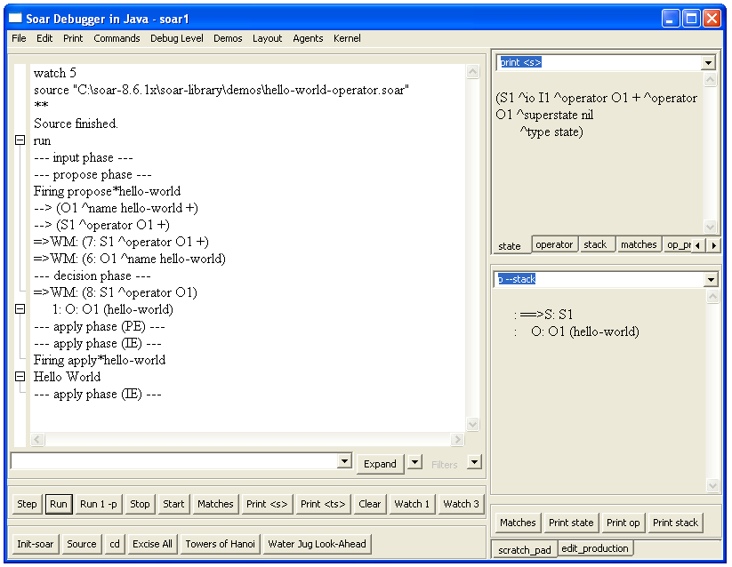
Operator proposed
Operator selected
Operator applied

3.2 Hello-World Operator: Soar Version
In this case, there is a one-to-one mapping of the English rules to Soar rules. The condition of propose*hello-world is the same as the condition for the original hello-world rule. The difference is in the action, where propose*hello-world proposes the hello-world operator. A rule proposes an operator by creating an acceptable preference for the operator. An acceptable preference is a statement that an operator is as a candidate for selection. The rule below proposes the hello-world operator:
sp {propose*hello-world
<s> in the action is replaced by the identifier matched by <s> in the condition
<o> is new in the action and is replaced by a new, unique identifier
(state <s> ^type state)
-->
+ indicates that this is an acceptable preference
(<s> ^operator <o> +)
<o> is replaced by the same identifier in all actions
(<o> ^name hello-world)}

The first action creates an acceptable preference for a new operator (which is added to working memory) and the second action creates a working memory element that augments the operator with its name.

A preference looks just like other working memory elements except that it has a fourth item: the type of preference, which in this case is “+”. The identifier of the preference is <s>, which means that the identifier matched to <s> in the condition is used in creating the action. For example, if working memory contained (s1 ^type state), then when this rule fired the preference would begin with (s1 ^operator. The value of the preference, <o>, is a new variable that did not occur in the condition. When new variables appear in actions, Soar automatically creates a new identifier and uses it for all occurrences of that variable in the action. For example, if o1 is the identifier created for <o>, then (s1 ^operator o1 +) and (o1 ^name hello-world) are added to working memory. For action variables such as <o>, a different identifier is created each time a rule fires.

Additional rules may create preferences to compare operators. The decision procedure selects an operator based on all the created preferences. If a single operator is proposed, that operator is selected. In this case, propose*hello-world fires creating a single acceptable preference for o1, and then the decision procedure selects o1 to be the current operator and adds (s1 ^operator o1) to working memory. Note that this augmentation does not have the “+” following the value. Only the decision procedure can add such an operator augmentation for a state to working memory (while proposal rules can add acceptable preferences for operators that differ by ending with the “+”).

Once the operator is selected, apply*hello-world should fire.
sp {apply*hello-world
Test that an operator has been selected
(state <s> ^operator <o>)
(<o> ^name hello-world)
-->
Test that the selected operator has name hello-world
Both occurrences of <o> must match the same identifier
(write |Hello World|)
(halt)}
This rule has exactly the same actions as hello*world, but with conditions that test that the operator hello-world has been selected. The first condition tests that some operator has been selected. We cannot include a specific identifier for the value (such as o1) because the exact value of the identifier can be different each time we run the program, so a variable, in this case <o>, is used.

The second condition tests that some object in working memory has name hello-world. The rule will only match if both <o>’s match the same identifier (such as o1). This is true for all variables in Soar; if the same variable shows up multiple times in the conditions of a rule, the rule will not match (and fire) unless all occurrences of the variable in the rule match the same symbol in working memory. In this case, they both match o1, and this rule fires.

If the same variable is used in multiple rules, it can match completely different identifiers or constants – that is, the identity of variables only matters within a rule. The exact symbols used in a variable are irrelevant, although as a general convention, <s> is usually used to match state identifiers and <o> is usually used to match operator identifiers.

3.3 Examining Working Memory
We can get an even more detailed look at Soar’s processing by examining the data structures in working memory. You can print out working memory in the Interaction Window using the print command. To print out all of the attributes and values that have s1 as the identifier, first click in the text box/pull down menu in the top right corner, and type print s1 followed by the “Enter” key. The debugger also has additional windows to the right of the Interaction Window that display common structures, such as the current state, the current operator, etc. The top most window should already show the state. This window has tabs for examining different structures in working memory. You can modify the command in these windows by typing in a new command (such as replacing “print s1” with “print s1 –d 2”), or you can add new tabs or create a new window that executes different commands. ,You do this by right clicking on a blank part of the window, and a menu will appear that let’s you create a new window or a new tab.

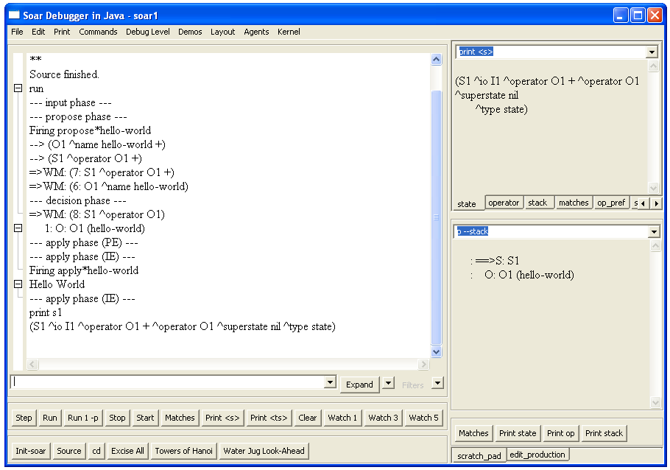
What you typed (s1 or S1 will work)
+ means an acceptable preference for an operator
O1 is selected operator

You now see all of the attributes and values that have S1 as their identifier. The attributes io, superstate, and type are created automatically for the state when the program starts to run. The operator attribute is created when the hello-world operator (o1) is selected. Only the selected operator has a working memory element such as this without the following “+”. In addition to the selected operator, the acceptable preference for the operator is there, marked with the "+". If there were additional operators proposed with acceptable preferences, there would be additional working memory elements with the operator attribute with the ids of the operators followed by the “+”, but for a given state there is only one working memory element with the operator attribute without the “+”, which signifies the selected operator. The attributes are ordered alphabetically when they are printed, but that is just to make it easier to find a specific attribute.

We can examine more of the structure of o1 using the print command. This time, select the operator tab or type p o1. The letter p means “print.” Almost all commands in Soar also have one or two-character shortcuts.
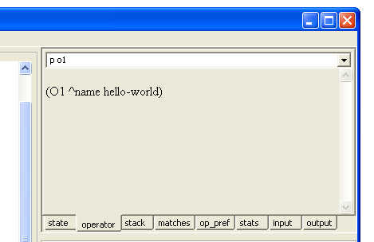

Operator o1 has an augmentation with attribute name and value hello-world. We can also examine the augmentations of some of the other values. I1 is the value of the ^io attribute, which stands for input-output. To see more about input and output, print I1. However, instead of using the print or p command, you can use the mouse to print information about I1. (If you don’t have a mouse, just use print.) To do this, type print s1 again as before and move the cursor over I1 in the tan window , then click the right mouse button. A menu will appear that has a list of commands: print, preferences, WMEs, productions, and run. Move the mouse over the print command and click the left button once.

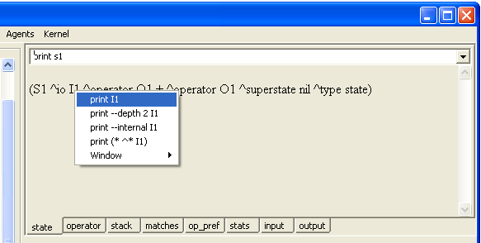

The information for I1 now appears in the Interaction window.

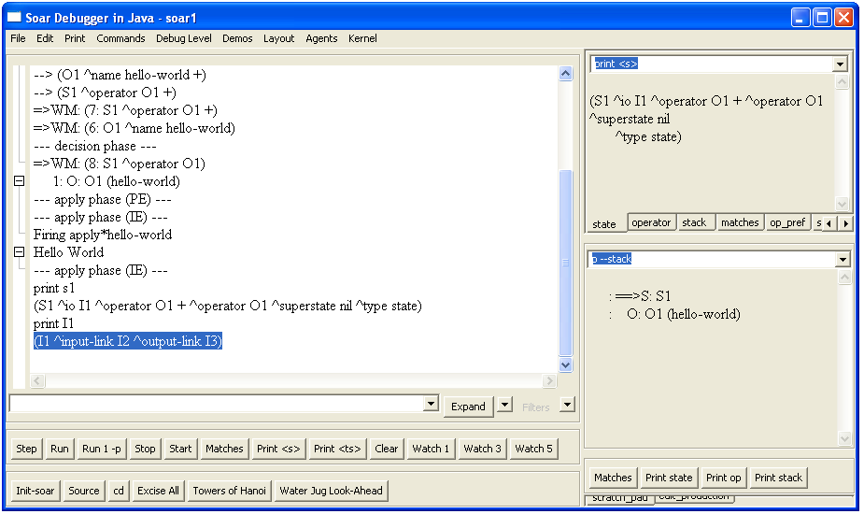

There are two attributes of io: input-link and output-link. The input-link is where an agent’s sensory information is available in working memory. The output-link is where action commands must be created for the agent to move in its world. Using the mouse, explore the structure of the input-link (I2). You can also try out some of the other commands available through the mouse, although we will work our way through them later in the tutorial.
^type
^superstate

S1

I1

I3

I2
Rules augment the value of the output-link with motor commands
Sensory information is added to the value of the input-link
^output-link
^io

^input-link

state

You now know the basic structure of rules and operators in Soar. You should be able to create your own agents that print out simple messages with operators.

3.4 An Introduction to VisualSoar
To create your own Soar programs, you can use almost any editor. We recommend VisualSoar because it has internal support for creating Soar programs. VisualSoar can be found in the same place that the Soar debugger was found. On launch, a fairly blank window entitled VisualSoar will pop-up. At the top, click File | New Project… and you will see a new pop-up window entitled New Agent. In the new window under Agent Name type “water-jug” (without the quotes) and under Agent Path, click Browse (if you receive a “no disk” error, ignore it by simply clicking continue) and locate the folder to which you want to save the project to. When this is done, click New.

You will see a new window on the left that should contain 5 things in the form of a tree. This is called the operator window. At the root is the name of your project, and the four things below it are the default files that are automatically created. The specifics of these four files will be explained as the tutorial proceeds. It is files like these that will contain the rules you write for an agent. The rules will be grouped into different files and file types depending on their function. It is from this window that you will control the way the rules are grouped together. The actual grouping of rules in VisualSoar is actually completely arbitrary to Soar but will make maintaining and debugging your code much easier for you. Due to this arbitrariness, do not feel that you can create an error by grouping your rules wrong.

One of the toughest parts of writing Soar code is visualizing the tree-like structure of working memory. VisualSoar has a structure called the Datamap for describing working memory structure. In some ways, it is like making type definitions in other languages. To examine the Datamap, right-click on the root of the tree entitled ‘water-jug’ and click on Open Datamap in the pop-up window. Doing this displays the hierarchical structure of the working memory of your agent in the Datamap water-jug window. VisualSoar not only lets you visually construct what memory should look like, it also lets you run tests to make sure your code follows the proper structure, automatically finding spelling mistakes, misplaced structures, and so on. You can close the Datamap water-jug window by clicking on the [x] in its top-right corner.

Throughout the rest of Part 1 of this manual you will write code to solve the water jug problem. Write this code into your Soar editor as you go. Once you get the hang of it, try and write the next step in the code before you look at it (make sure to double-check it with our code of course).

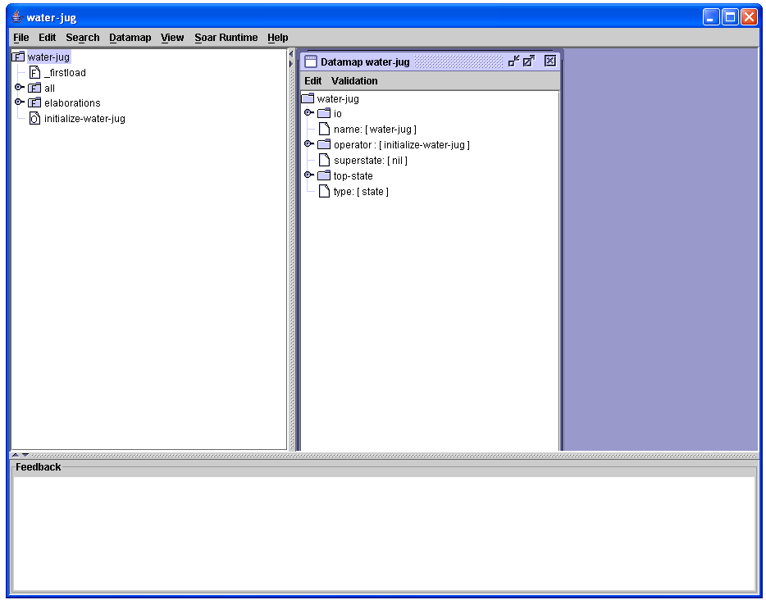
The root of the tree and the name of your project, click here to open the Datamap
This is the Operator window
This is the Feedback window
This is the Datamap for water-jug

4. Creating Agents to Solve the Water Jug Problem
This part of the tutorial will teach you how to build Soar programs that solve problems through internal problem solving. You will build a Soar program for a classic AI problem: The Water Jug. Other classic AI problems, including Blocks World, the Eight Puzzle, Missionaries and Cannibals, and Towers of Hanoi are included in the set of demonstration programs that comes with the Soar release. The Soar programs you develop will solve these problems through search and the manipulation of internal data structures. You will start by building the operators, state descriptions, and goal tests that are required to define the problem. You will also be introduced to more of the theory of problem solving based on search in problem spaces. In Part V, you will learn how to modify and extend to your programs so that they use planning and learning to solve problems. If you run into problems debugging your programs, you might want to skip ahead to Part II, Section 5.3, which contains details on debugging commands for Soar.

4.1. Water Jug
Water Jug Problem Statement:
You are given two empty jugs. One holds five gallons of water and the other holds three gallons. There is a well that has unlimited water that you can use to completely fill the jugs. You can also empty a jug or pour water from one jug to another. There are no marks for intermediate levels on the jugs. The goal is to fill the three-gallon jug with one gallon of water.

The first step in formulating a problem is determining the space of possible states that the problem solver can be in. The space of states, or problem space, is determined by the objects that are available to be manipulated (the two jugs) and their possible values (0-5 gallons full). A problem is then defined as an initial state that the problem solver starts at, (in this case two empty jugs) and a set of desired states (any state where the three-gallon jug has one gallon of water). Problem solving consists starting at the initial state, then searching for a desired state by applying operators, which transform one state into another. For the water jug problem, the operators are fill a jug, empty a jug, and pour from one jug to the other.

In addition to the knowledge required to formulate the problem, knowledge can be used to select which operator to apply at each state. In the water jug, you might have knowledge that specifies never emptying a jug immediately after it has been filled. In Soar, this knowledge is often called search control knowledge, because operator selection is the locus of all decision making in Soar. It is the one place where multiple alternatives can be proposed, compared and evaluated before a selection is made. An important part of Soar’s design is that it makes it possible to separate all of the problem formulation knowledge from the knowledge that is used to control the search.

At an abstract level, a trace of the problem solving starts with the creation of the initial state and is followed by the selection and application of operators. To represent the states in the water jug problem, we will have two values: the amount of water in the five gallon jug, and the amount of water in the three gallon jug. For example: 5:0,3:0 will represent that the 5 gallon container has 0 gallons of water, and the 3 gallon container has 0 gallons of water. Below is a trace of the optimal solution for the problem showing the states and the operators that are applied to each state.

(5:0,3:0) Fill 3 gallon jug
(5:0,3:3) Pour 3 gallon jug into 5 gallon jug
(5:3,3:0) Fill 3 gallon jug
(5:3,3:3) Pour 3 gallon jug into 5 gallon jug
(5:5,3:1)

The rest of this section will take you through all of the steps of representing the problem in Soar, including determining the representation of the states in working memory, creating the initial state, representing the operators in rules (and working memory), and so on.

4.2 State Representation
For tasks that involve interaction with the outside world, much of the state structure is determined by what comes in via perception. For the water jug problem, we could hook up Soar to a water jug simulator (or real world robot) and have it issue commands to pour water into and out of jugs, but to simplify learning Soar, we will have Soar solve the problem through the manipulation of internal data structures. . Moreover, this will prepare you for planning, where your program will need to create an internal representation of the problem even if there is an external world.

What are the parts of the problem that must be represented on the state? There are really two types of information: dynamic information that changes during problem solving, such as how much water is in each jug, and static information that doesn’t change, such as the size of each jug.

So one state representation might include:
- The amount of water each jug currently holds.
- The amount of water each jug can hold.
You can combine these together by having the volume of the jug as an attribute with the value being the current contents. Under this scheme, the initial state would look something like:
(state <s> ^five-gallon-jug-contents 0
^three-gallon-jug-contents 0)
This is a very compact representation; however you will have to write very specific rules for proposing and applying operators. You will need one set of rules to propose the operators for the five-gallon jug and one for the three-gallon jug.

A more general approach would be to represent each jug as an object that had two attributes:
- The amount of water each jug currently holds (^contents).
- The amount of water each jug can hold (^volume).
In this scheme, the initial state would look something like this.
(state <s> ^jug <j1>
^jug <j2>)
(<j1> ^volume 5
^contents 0)
(<j2> ^volume 3
^contents 0)
Note that jug is an attribute that can have multiple values at the same time. We call this a multi-valued attribute. Multi-valued attributes allow you to represent sets of objects, such as the set of two jugs.

Using this representation, you can write one set of rules for manipulating both jugs. Although this representation is sufficient for defining and solving the problem, as you will see later, the rules to propose operators can be simplified if you add an attribute for the amount of water that can be added to a jug to fill it (^empty). As you will see later, the value of this augmentation can be computed dynamically using state elaboration rules that test the volume and contents augmentations and subtract the volume from the contents. Thus, states will include the following structures:
- An object for each jug (^jug).
- The amount of water each jug can hold (^volume).
- The amount of water each jug currently holds (^contents).
- The amount of empty space available in each jug (^empty).
Although this representation is sufficient, one more working memory structure is extremely useful: a description of the task that is being attempted, in this case water-jug. By having some description of the task, the rules we create can be specific to that task and easily combined with rules from other tasks without interference. Thus, a common Soar convention is to label the state with information about the task being attempted. The simplest approach is to have a ^name attribute, where the value is the name of the task. For some tasks, other information is useful, but this will be sufficient for the water jug task.
- The task name (^name water-jug)

4.3 Initial State Creation: The initialize-water-jug Operator
In order for Soar to start on a problem, the structures of initial state must be in working memory. For tasks involving interaction with an external environment, much of the state will be created by the perceptual information that comes in from sensors. That information would be created on the input-link structure of the state. But for this task, we are assuming there is no external environment, so the initial state must be created by rules that you add to the system.

Thus, the first step is to define an operator that will create the initial state. By using an operator instead of a single rule, the act of initialization is a choice that can be controlled – that is, the operator to initialize the problem will be proposed and a decision will be made whether to do it. If other tasks are possible, the agent can decide which task will be attempted by using control knowledge to pick among the different initialization operators.

The first step in creating an operator is to write down the proposal rule in English.

Type the English versions of the proposal and application rules for the initialize-water-jug operator. These versions will be documentation, so we have to tell Soar to ignore them. You can do this by starting each line with the pound-sign (“#”). Soar ignores lines that start with a pound sign.

In Soar, the name of the rule can be almost any string of characters, but it is a good idea for it to be a meaningful summary of the purpose of the rule. A useful convention is to split the name into parts separated by asterisks (“*”). The first part is the task, the second part is the function (propose, apply, elaborate), and the third is the name of the operator. There may be additional parts for more details of what the rule does.

As with every operator, we must define two types of rules: one to propose the operator and one to apply the operator. This operator should be proposed only at the beginning, before any task is selected. Thus, the proposal should be:

water-jug*propose*initialize-water-jug
If no task is selected,
then propose the initialize-water-jug operator.

Writing this rule in Soar is a challenge given what you know so far. How can you test that no task has been selected or that no jugs are defined? In Soar it is possible to test for the absence of working memory elements by preceding the attribute with “-“. Every rule in Soar must have at least one positive condition, so you still need to test that the state exists and in this case we use (^superstate nil).

sp {water-jug*propose*initialize-water-jug
Test that there is no task.
(state <s> ^superstate nil)
-(<s> ^name)
-->
(<s> ^operator <o> +)
(<o> ^name initialize-water-jug)}

VisualSoar – The purpose of this production is to propose the operator that will initialize the water-jug. If you look at the operator window in VisualSoar you will see that the file at the bottom is titled “initialize-water-jug.” This is created automatically when you created the water-jug project because a standard practice is to use an initialization operator for a new task. Either double-click on that file or right-click on the file and click Open Rules. This will open up a rule editor in which you will see two rules already partially written. The initialization written above is a very standard one, and because of this VisualSoar automatically creates a template of it for you (it is the first rule at the top). It may look a little different because VisualSoar uses a few shortcuts that you will learn later, feel free to leave it how it is or change it to the way it is above, it will not matter. Leave this rule window open.

Just a reminder that the order of the conditions don’t matter except that the first condition must be a positive test of the state. Thus, there is no difference between the above rule and one where the test for the absence of the jug comes before the absence of the name. Soar analyzes the rule and automatically reorders the conditions in order to improve the efficiency of matching the rules.

The second condition will match only if there is not any working memory element on the state with attribute name. The condition does no test for a value, because it doesn’t matter what the value is. You could include variables in the value position (such as <name>) if you wanted, and that would not change the meaning of the rule.

All the conditions test attributes of the same object (the state), and you can simplify the rule by combining these conditions (just as VisualSoar did) into a single structure where the identifier (<s>) is followed by the attributes:

sp {water-jug*propose*initialize-water-jug
(state <s> ^type state
-^name)
-->
(<s> ^operator <o> +)
(<o> ^name initialize-water-jug)}

Soar automatically translates this structure into the one above.

To apply this the initialize-water-jug operator, we need another rule. The initialization application rule adds the name to the state and creates the jugs with contents of 0. The rule needs to add working memory elements for the initial values of the jugs and their attributes.

water-jug*apply*initialize-water-jug
If the initialize water-jug operator is selected,
then create an empty 5 gallon jug and an empty 3 gallon jug.

sp {water-jug*apply*initialize-water-jug
(state <s> ^operator <o>)
(<o> ^name initialize-water-jug)
-->
(<s> ^name water-jug
^jug <j1>
^jug <j2>)
(<j1> ^volume 5
^contents 0)
(<j2> ^volume 3
^contents 0)}

This rule does not include the creation of the ^empty attribute – it will be created by another rule that dynamically computes it based on the volume and contents (see Section 4.5).

VisualSoar – In the initialize-water-jug rule window you will notice that VisualSoar has attempted to write this rule for you also. The application of initializing the water-jug is not as standard as the proposal and VisualSoar is not able to initialize all of the attributes that this project will need. Modify the second rule in the rule window to match the rule above.

Now, at the top of VisualSoar, click on Datamap | Check All Productions Against the Datamap. In the feedback window at the bottom you will see a list of blue warnings. What you just did was make VisualSoar check all of your rules to see if they matched the Datamap for this project. Recall that the Datamap is a representation of the structure of working memory. Since you just added new augmentations to the state in your rule, but not to the Datamap, warnings are created. To fix this, right-click in the operator window on “water-jug” and click on Open Datamap so that now you have the Datamap and initialize-water-jug windows open. You will notice that VisualSoar has already included the structure for the Initialize-water-jug operator – this is automatically created whenever a new operator is added to the operator set. The Datamap is a hierarchical structure that looks like folders and files as in the operator window, but it is really the structure of working memory. The folders are used to represent working memory elements (such as operator) whose values are identifiers, and thus can have substructure. The file-like structures are attributes that have constants as values – either sets of symbols (enumeration), integers, floating point numbers (floats), or strings. You must now add entries into the Datamap for the water-jug state structure.

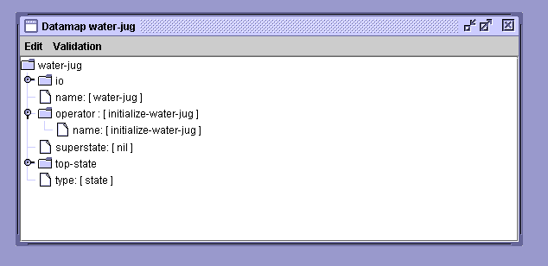
Initialize-water-jug operator – automatically created
File-like structures for attributes with constant values: integers, floats, strings, enumerations
Folder structures for attributes with identifier values, which can have substructure

What you need to add to the Datamap are the jug structures that are created by initialize-water-jug and that will be used by the remaining operator. In order to add a new attribute to the Datamap, you start by right clicking on the “water-jug” folder in the Datamap (not in the operator window). The water-jug folder in the Datamap represents the top-state structure in Soar. After right-clicking, a menu will appear that let’s you select the type of value that will be associated with the attribute you are creating. Since the jug attribute will have an identifier as its value, select “Add Identifier …”

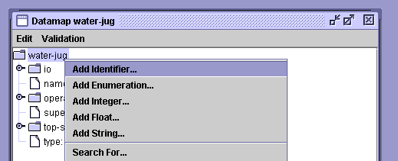

You will then be prompted for the attribute name. Type in “jug”.

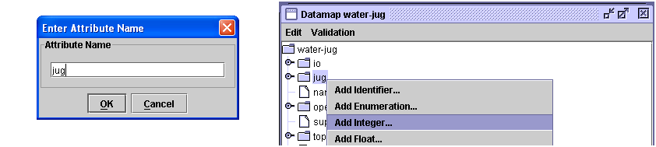
The folder “jug” has been added to the Datamap.

This will add the jug structure to the Datamap. You can now right click on the jug structure, and select “Add Integer …” to add the contents attribute to the jug structure. Type in the name, and then repeat this for the empty and volume attributes. If the attribute had values that were different possible symbols, you would use the “Add Enumeration …” selection. Your screen should now look like this:

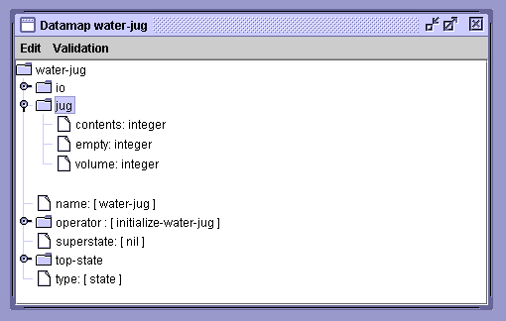

Now have VisualSoar check all productions against the Datamap (using the command under the Datamap tab in the toolbar), you should have no errors. Make sure to save and feel free to close the Datamap and initialize-water-jug windows.

In the above rule, the variable <o> is used to connect the first condition to the second. To simplify the writing and reading of rules, Soar allows you to combine conditions that are linked by variables. To do this, you can just string together attributes, replacing the intermediate variables with a period, “.”, to separate the attributes. In Soar, we call this “dot” or “path” notation. Below is the same rule as before using dot notation.
. replaces <o>
sp {water-jug*apply*initialize-water-jug
(state <s> ^operator.name initialize-water-jug)
-->
(<s> ^name water-jug
^jug <j1>
^jug <j2>)
(<j1> ^volume 5
^contents 0)
(<j2> ^volume 3
^contents 0)}

4.4 Persistence of Working Memory Elements
When the water-jug*apply*initialize-water-jug rule fires, all of the structures in its action are added to working memory. At this point, it would be desirable for the initialize-water-jug operator to be removed from working memory so that other operators can be selected. This is exactly what Soar does because the conditions of the proposal rule no longer match (the conditions testing for the absence of a task and the absence of the jug augmentation fail to match because those structures have been added to working memory). Once that rule retracts, the rule that applied the operator also no longer matches because the operator is no longer in working memory. However, we do not want the application rule to remove the structures it created when it no longer matches. If it did, the system would never be able to make any real progress – it would get in an infinite loop of proposing and applying an operator, retracting its results, and then proposing and applying the operator again.

In order to support the different needs of different problem solving functions (in this case operator proposal and operator application), Soar makes a distinction between the persistence of working memory elements created by operator application rules and the persistence of working memory elements created by other types of rules. Operator application needs to create persistent results because operators are the deliberate commitments that the system has made – it has decided to apply the operator and make potentially non-monotonic changes to the state – to move itself to a new state in the problem space. All other rules in Soar compute the entailments/elaborations of the current state without actually changing it and should be retracted when they no longer match the current state. This is a very important feature of Soar – it makes a distinction between knowledge that modifies the current state (knowledge in operator applications), and knowledge that just computes the entailments of the current situation (including which operators should be considered for the current state).

Soar automatically classifies rules as to whether they are part of an operator application or not. A rule is an operator application rule if it tests the selected operator and modifies the state. The working memory elements created by such a rule persist and are said to have operator-support, or o-support because they are created as part of an operator. These working memory elements can be removed by other operator applications rules (this type of removal has yet to be introduced in the tutorial), or if they become disconnected from the state (because of the removal of other working memory elements).

For non-operator application rules, including rules that propose an operator, rules that compare operators, rules that elaborate operators, or rules that elaborate the state, the working memory elements created by the rules are removed from working memory if the rule no longer matches. These working memory elements are said to have instantiation-support or i-support – meaning they will persist only as long as the rule instantiation that created them still matches.

We will examine the persistence of working memory elements in more detail when we create the rules for the Water Jug, but this is a fundamental and sometimes difficult part of Soar for people to learn. It differentiates Soar from most other rule-based systems that don’t have rules that automatically retract their results when they no longer match and it gives Soar its own Truth-Maintenance System (TMS).

4.5 Water Jug State Elaboration
The initialization operator creates jugs that include the volume and content. As mentioned earlier, it will be useful for each jug to include the amount of additional water that can be added to it before it is full. Although this could be created by the initialization operator, it would have to be maintained by every operator application and that would make the operator application rules more complex. An alternative is to compute the available volume for each jug in the state with a separate rule. This rule will test the state and create a new structure on the state. This type of rule is called a state elaboration rule. State elaboration rules are ubiquitous in large Soar systems because they can create useful abstractions of combinations of other working memory elements and represent them directly on the state as a new augmentation. These new augmentations can then be tested in other rules in place of complex combinations of conditions, simplifying rules and making the structures in working memory more meaningful. A critical aspect of state elaboration rules is that they create i-supported working memory elements so that when the parts of the state they test change, they recompute their actions automatically.

For the Water Jug problem, the state elaboration will compute the amount of empty space in a jug:

water-jug*elaborate*empty
If the state is named water-jug and a jug can hold volume v and currently has contents c, then add that it has v – c available (empty) space.

The first condition that it tests is that the state is named water-jug, so that it will only apply for water-jug problems. This test will be included in all of the water jug rules. It then tests that there is a jug and adds an appropriate empty attribute. Translating the conditions of this rule to Soar is straightforward. We have to include conditions for the jug, its volume and its contents.

The action requires adding a new attribute to the jug (thus using the same variable as matched in the condition, <j>) and then computing the value by doing some math. In Soar, all math is done using prefix notation where the math operations (+, -, *, /) come before the arguments, with parentheses surrounding the computation. For example, if the value was going to be the sum of <v> and <c>, you would put (+ <v> <c>) where the value should be (right after the ^empty attribute). You can nest operations using additional parentheses, such as (+ 2 (* <v> <c>)) to add 2 to the product of <v> and <c>, but for this case, nesting is not necessary. See if you can write the rule yourself before looking below:

sp {water-jug*elaborate*empty
(state <s> ^name water-jug
^jug <j>)
(<j> ^volume <v>
The value for this augmentation is the result of the subtraction.
^contents <c>)
-->
(<j> ^empty (- <v> <c>))}

When the contents of a jug changes through an operator application rule, this rule will retract the old value of ^empty and fire to compute a new value.

VisualSoar – This rule is an elaboration. VisualSoar has a folder named elaborations in the operator window to hold files for state elaborations. Right-click on this folder and click “Add a File…”. You will see a text box pop-up. In the Name category type “empty” and click OK. Expand the elaborations folder and you should see the file you just created and two default files named “_all” and “top-state.” These files are provided for all Soar programs and have a few simple rules that are useful for tasks with substates. You should now open the “empty” file by double clicking on it. You can add the rule from scratch and just type it in, or you can use a template. To use a template, click on Insert Template in the toolbar and select elaborate-state. That will give you the basic structure of an elaboration rule. Just as before, check your file against the Datamap.
4.6 Water Jug State Initialization and Elaboration
At this point you should have written your initialization rule and the state elaboration rule into your Soar editor. Make sure to save this file then start up the Soar Debugger and load these rules in using the source command.

Now set the watch level to 5 and expand the trace so you can see rules fire and the creation on working memory elements.

As you step through the execution,
- The water-jug*propose*initialize-water-jug rule fires to propose the initialization operator. Expand the plus sign next to 1:O: O1 (initialize-water-jug)
- The operator and the acceptable preference for it are added to working memory: (s1 ^operator o1 +), (o1 ^name initialize-water-jug). The “+” signifies that the operator is proposed and not selected.
- The initialization operator is selected by the decision procedure.
A working memory element is added to working memory to indicate that the operator is selected: (s1 ^operator o1). Note that the operator preference is still in working memory.
- The application operator fires and creates the jugs on the state and the name.
- The operator proposal retracts because the condition that tests for the absence of the name fails and the water-jug*elaborate*empty rule fires twice, once for each jug, and computes the empty augmentation for each of the jugs.
- A substate is created (ignore for now) because there are no other rules to fire.
Note that in number 4, water-jug*elaborate*empty fires twice because there are two jugs and this rule matches successfully with each jug. Each of these matches is called an instantiation. An instantiation consists of a set of working memory elements that successfully match a rule. In this case, there will be two sets of three working memory elements that are completely separate. Sometimes a rule will have multiple instantiations that share some of the same working memory elements, while in other cases such as this one, they are all different.

Given that there are two instantiations, which one should fire first? There really is no way to say that one is more important than another, and in Soar, we attempt to avoid decisions when we really don’t have to make them, so in Soar, all rules that newly match fire at the same time, in parallel. Of course the Soar program is running on a serial computer (usually), so it isn’t really in parallel, but for all intents and purposes, the rules fire in parallel. This is very different than most programming languages and can be confusing (and liberating) because you will find that rules fire as soon as they match.

Below is a more complete look at Soar’s basic cycle. For this problem there is no input and output, so those boxes are skipped. Starting at the left, rules fire (or retract) that elaborate the state or propose operators. There might be multiple rules firing (or retracting) in parallel, and the results of one rule firing (or retraction) might lead to additional rules firing (or retracting), and Soar continues to fire these waves of rules until there are no new firings (or retractions). Once there are no more rules to fire (or retract), quiescence is reached and the decision procedure is entered to select the operator. This approach guarantees that when a decision is made, all of the available knowledge from rules is available.

After the operator is selected, rules that apply the operator can fire. Operator application will usually lead to firing and retracting of state elaboration and operator proposal rules and that will also happen during the operator application phase. When that phase reaches quiescence, output and then input are processed followed by the first phase described above. In tasks where there is an external environment, many operators require action in the world, and so changes to the state will appear during input. In the water jug task, all state changes happen in operator application, so that the elaborate state and propose operator phase do not lead to additional rule firings after the first time through the cycle.
Elaborate State
Propose Operators
Apply Operator

Select Operator
Output
Input

4.7 Water Jug Operator Proposals
In the Water Jug problem, there are three operators: fill, empty, and pour. In this section we will create the rules that propose these operators. One thing Soar lets us do is separately compute when an operator can apply (proposal rules that create acceptable preferences for operators) from when it should apply (search control rules that create other types of preferences).

Listed below with each operator are the conditions under which an operator is legal. These conditions will be the basis for the operator proposals.
- Fill a jug with water from the well, if that the jug is not full.
- Empty the water from a jug to the well, if there is water in the jug.
- Pour water from one jug to another jug, if there is water in the source jug and the destination jug is not full.

Although one could attempt to fill a jug that is already full; in Soar, operators must change the state in some way so that another operator can be selected. Thus, in our formulation, filling a full jug must be disallowed. Now write English descriptions of the proposals.

water-jug*propose*fill
If the task is water-jug and there is a jug that is not full,
then propose filling that jug.

water-jug*propose*empty
If the task is water-jug and there is a jug that is not empty,
then propose emptying that jug.

water-jug*propose*pour
If the task is water-jug and there is a jug that is not full and the other jug is not empty,
then propose pouring water from the second jug into the first jug.

Each of these rules can potentially match either one of the jugs.

In translating these rules into Soar, we need to write the tests in the conditions, but we also need to write actions that will create the operator. The hello-world and initialization operators were just a name; however, with these new operators, you want to have some parameters that specify which jugs are being filled, emptied, or poured. If you really wanted to, you could encode everything in the name of the operators, but then we would need six different operators, such as “fill-jug-three” or “pour-jug-five-into-jug-three”, and this would require separate rules to apply each of those operators. Instead, by having parameters with the operators, you can have fewer rules that apply the appropriate changes to the state. For this task, a set of operator parameters and possible labels are listed below:
- The name of the operator: ^name fill/empty/pour.
- The jug that is being filled by the fill operator: ^fill-jug <j>.
- The jug that is being emptied by the empty operator: ^empty-jug <j>.
- The jug that is being poured out of by pour: ^empty-jug <j1>.
- The jug being poured into by pour: ^fill-jug <j2>.

For example, with this representation, the operator representation for pouring from jug <j1> to <j2> would be:
(<o> ^name pour
^empty-jug <j1>
^fill-jug <j2>)

There are lots of other possibilities and it is not necessary to share the name of the parameters between the pour operators and the others.
Now try to write the first proposal as a Soar rule for proposing fill. The only test besides the name of the state is that the jug is not full. Using what you know already, one way to write this rule is:

sp {water-jug*propose*fill
(state <s> ^name water-jug
Tests that the jug does not have 0 available space – it is not full.
^jug <j>)
(<j> -^empty 0)
-->
(<s> ^operator <o> +)
(<o> ^name fill
^fill-jug <j>)}

This rule tests that jug <j> does not have an empty augmentation of 0. This is a double negative, and although correct in the context of what has been written, it is difficult to understand. An alternative is to test that the ^empty augmentation has a value greater than 0. Soar supports simple tests in conditions including greater than (>), greater than or equal (>=), less than (<), less than or equal (<=), and not equal (<>). The tests are associated with the value (or variable) that follows them. So an alternative way to write this rule is:

sp {water-jug*propose*fill
(state <s> ^name water-jug
Numeric comparison in condition:
Tests that value must be greater than zero
^jug <j>)
(<j> ^empty > 0)
-->
(<s> ^operator <o> +)
(<o> ^name fill
^fill-jug <j>)}

Another alternative condition would be to replace the test of empty being greater than zero with a test that the contents don’t equal the volume: (<j> ^volume <v> ^contents <> <v>).

One alternative that is not possible is to do some simple math in the conditions to test whether the volume minus the contents equal 0. Soar does not allow any match in conditions – you should use elaborations instead so that the math is always done in actions.

VisualSoar – If you look in the operator window in VisualSoar, you will not see anything relating to a “fill” operator . You need to create a new operator file that will hold all of the rules related to fill. To do this, right-click on “water-jug” in the operator window and click on “Add a Suboperator…”, name it “fill” and click OK. Open the newly created fill operator and add the rule above (using the propose operator templates).

When finished adding the rule, open the Datamap. You will notice that an operator structure for fill has automatically been created, but you need to add empty-jug as an attribute. The value for empty-jug is an identifier, but it is really the same structure as a jug on the state. So instead of creating a new empty-jug structure from scratch, we want to create a “link” from empty-jug to the state jug structure. Note, we don’t want a copy of the jug structure, because if the jug substructure changes, we want those changes reflected in the empty-jug structure. To create the link is the “trickiest” operation in VisualSoar. First, left-click and hold (don’t let up on the left-mouse button!) on the “jug” structure on the state. Then with drag that structure onto the fill operator structure in the Datamap. If you let up on the button now, it would move the jug structure, but we want to create a link. To do that, hold down the “ctrl” and “shift” keys (usually with your left hand). This should make a new icon appear that has a little arrow (see diagram below). Then let up on the mouse button (while keeping “ctrl” and “shift” down. This will create an attribute of the operator with name “jug”. (Note: sometimes the display of the Datamap in VisualSoar is not correctly updated. You might need to close the Datamap and reopen it for it to refresh correctly).

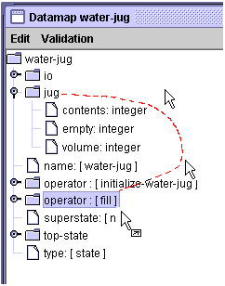
Holding down ctrl + shift while pressing the mouse button will change the mouse icon.
Release mouse, then release ctrl + shift while over top of the operator : [ fill ] folder.
Click and hold down left mouse button
Drag mouse to the operator : [ fill ] folder

At this point, you should rename the attribute. Do this by right-clicking on the attribute, and then select “Rename Attribute …” from the menu. Type in “empty-jug” and then click OK.

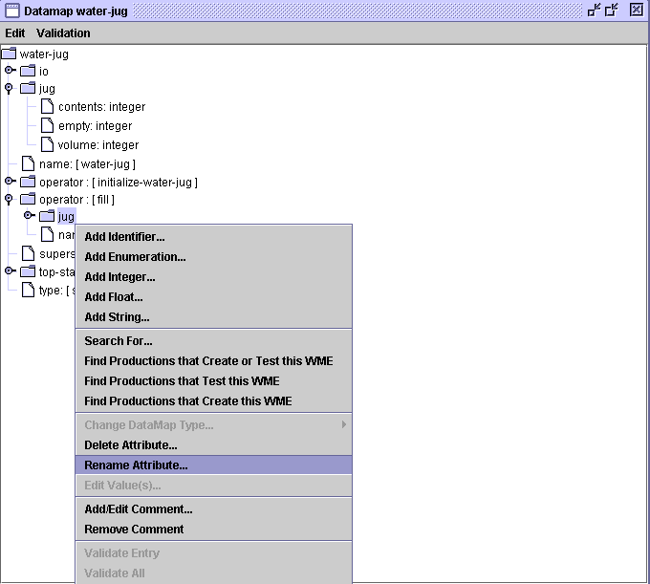
jug has been linked to operator : [ fill ]

Now try to write the proposal for emptying a jug. This requires only minimal changes to the previous rule, changing the test that a jug is not full to a test that the jug is not empty.

sp {water-jug*propose*empty
(state <s> ^name water-jug
^jug <j>)
(<j> ^contents > 0)
-->
(<s> ^operator <o> +)
(<o> ^name empty
^empty-jug <j>)}

VisualSoar – This is very similar to before. Add a suboperator (just like “fill”) called “empty” to water-jug, type in the rule, and create the Datamap entries for it.

Writing the third proposal for pour requires a test that one jug is not empty (so it can have water poured from it) and the other jug is not full (so water can pour into it). You might think that this is a simple combination of the tests in the previous two rules so that the rule should be:

sp {water-jug*propose*pour*wrong
(state <s> ^name water-jug
Incorrect: both <j> and <i> could match same jug.
^jug <i>
^jug <j>)
(<i> ^contents > 0)
(<j> ^empty > 0)
-->
(<s> ^operator <o> +)
(<o> ^name pour
^empty-jug <i>
^fill-jug <j>)}

This rule is not correct because the tests for jug <i> and jug <j> can match the same jug. That is because there is nothing in Soar that prevents different conditions from matching the same working memory element. For example, if working memory holds (s1 ^jug j1) (j1 ^contents 3 ^empty 2 ^volume 5), this rule would create a proposal for a pour operator that would pour from jug j1 to itself because it would successfully match the conditions for both <j> and <i>. To correct this rule, the conditions must be modified so the <i> and <j> can not match the same identifier, that is, that <j> is not equal to <i>. That test in Soar is <> <i>. But where should that test be added in the rule? In Soar, multiple tests of a value (and multiple tests for an identifier or attribute) can be specified by surrounding all of the tests with curly brackets: { … }. In this case, we can combine the test for <j> with <> <i> to be {<j> <> <i>}. This demonstrates both the use of curly brackets and the use of not equals. Note that the test could also be { <> <i> <j> } and it would mean exactly the same thing – what matches in this position cannot equal <i> and must equal <j>.

sp {water-jug*propose*pour
(state <s> ^name water-jug
Correct: match <j> and not equal to <i>.
Must have space before and after <>.
^jug <i>
^jug { <j> <> <i> })
(<i> ^contents > 0)
(<j> ^empty > 0)
-->
(<s> ^operator <o> +)
(<o> ^name pour
^empty-jug <i>
^fill-jug <j>)}

VisualSoar – Once again this is very similar to before. Add a suboperator (just like “fill”) called “pour” to water-jug, type in the rule, and add the Datamap entries for it.

Now that you have all of the proposals written, you can load them in with your other rules. What happens when you run them? You will see that only water-jug*propose*fill matches in the initial state. It fires twice since it matches both jugs, right after ^empty is added to each jug. What happens next? When Soar does not have enough knowledge to select between the two operators, it has a tie impasse and it automatically creates a substate where it can do reflective problem solving to decide what to do next. We will cover substates in a later section. For now, we just want Soar to select randomly between these operators. You can tell Soar that it doesn’t matter which operator is selected by creating an indifferent preference, using “=” for the operator. This can be created in the same rule that proposes the operator.

sp {water-jug*propose*fill
(state <s> ^name water-jug
^jug <j>)
(<j> ^empty > 0)
Indifferent preference will lead to a random selection and avoid an impasse.
-->
(<s> ^operator <o> +
^operator <o> =)
(<o> ^name fill
^fill-jug <j>)}

The two actions for ^operator can be shortened by using just:
(<s> ^operator <o> + =)
which means create an acceptable and indifferent preference (you always need the acceptable preference, even if there are other preferences created). You should modify all of the operator proposals to include the = preference.

4.8 Operator Application
The next step is to write the operator application rules that will fire once an operator is selected. In the Water Jug problem, your rules apply operators by adding and removing working memory elements to reflect the pouring of the water.

What keeps the operator application productions from applying over and over again? When the operator rules apply, they change the part of the state either directly (through rules that change working memory) or indirectly (by doing some action in the world that changes what the Soar agent perceives – more on that in later sections). These changes will cause the acceptable preference for the selected operator to retract because at least one of the working memory elements that matched the proposal rule changed. The changes to working memory will cause new matches of proposal rules, which will be followed by the selection of a new operator, its application, and so on.

Given the state representation used in this problem, there are two different ways that the operators can change the state representation. The most straightforward is to add and delete the ^contents attributes of the jug objects. However, the operators could also remove a jug and create a completely new jug object with the correct contents and volume attributes. Although this is less efficient, it has some advantages for planning and we will return to this approach in Part IV. For now you should write operator application rules that modify the ^contents attribute of the jug objects (it is not necessary to modify the ^empty attribute because it will be automatically recomputed whenever the ^contents change).

In the Water Jug, there are three separate operators and each ones requires its own operator application rules. We will examine them one at a time. The first is fill. Try to write an English version of its operator application rule.

water-jug*apply*fill
If the task is water-jug and the fill operator is selected for a given jug, then set that jug’s contents to be its volume.

This rule requires replacing the current value of the contents with a new value (the volume). To replace a value in Soar, you must remove the original working memory element and create a new one. There is no way to just replace the value field in an existing working memory element. This is an important attribute of Soar – all changes require the addition or deletion of working memory elements. You cannot modify a working memory element once it is created. You already know how to create a working memory element. To delete one, you specify the working memory element in the action but with a minus “-“ at the end.

sp {water-jug*apply*fill
(state <s> ^name water-jug
^operator <o>
^jug <j>)
(<o> ^name fill
^fill-jug <j>)
(<j> ^volume <volume>
^contents <contents>)
-->
(<j> ^contents <volume>)
To remove a working memory element, use “-“.
(<j> ^contents <contents> -)}

VisualSoar – In VisualSoar, we group all of the rules for an operator in a single file. In this case, you should reopen the fill operator file, and add this rule (using a template) directly under water-jug*propose*fill.

The rule to apply the empty operator is essentially the inverse of fill.

water-jug*apply*empty
If the task is water-jug and the empty operator is selected for a given jug, then set that jug’s contents to be 0 and its empty to be its volume.

sp {water-jug*apply*empty
(state <s> ^name water-jug
^operator <o>
^jug <j>)
(<o> ^name empty
^empty-jug <j>)
(<j> ^volume <volume>
^contents <contents>)
-->
(<j> ^contents 0
To remove a working memory element, use “-“.
^contents <contents> -)}

This rule shows a shortcut in that two changes to working memory that involve the same identifier can be written without repeating the identifier.

VisualSoar – Once again, put the application of empty in the same file that holds the proposal of empty.

The pour operator is more complex because there are two different situations. One situation is where pouring the water into the jug being filled can hold all of the water being poured in, such as pouring from the three gallon jug into an empty five gallon jug. The other situation is where the jug being filled cannot hold all of the water, so that some water is left in the source jug, such as when pouring from the full five gallon jug into an empty three gallon jug. As a result, we have to write two rules that cover these two situations.

water-jug*apply*pour*will-empty-empty-jug
If the task is water-jug and the pour operator is selected,
and the contents of the jug being emptied are less than or equal to
the empty amount of the jug being filled,
then set the contents of the jug being emptied to 0;
set the contents of the jug being filled to the sum of the two jugs.

sp {water-jug*apply*pour*will-empty-empty-jug
(state <s> ^name water-jug
^operator <o>)
(<o> ^name pour
^empty-jug <i>
^fill-jug <j>)
(<j> ^volume <jvol>
^contents <jcon>
^empty <jempty>)
(<i> ^volume <ivol>
^contents { <icon> <= <jempty> })
-->
(<i> ^contents 0
^contents <icon> -)
(<j> ^contents (+ <jcon> <icon>)
^contents <jcon> -)}

VisualSoar – Put this rule, along with the next one, into the file containing the proposal for pour.

This rule shows why it is useful to have the ^empty augmentation on the jugs. Without it, it would be very difficult to have the test that the jug being filled could hold the water from the jug being poured from.

water-jug*apply*pour*will-not-empty-empty-jug
If the task is water-jug and the pour operator is selected, and
the contents of the jug being emptied are greater than the empty amount
of the jug being filled,
then set the contents of the jug being emptied to its contents minus the
empty of the jug being filled;
set the contents of the jug filled to its volume.

sp {water-jug*apply*pour*will-not-empty-empty-jug
(state <s> ^name water-jug
^operator <o>)
(<o> ^name pour
^empty-jug <i>
^fill-jug <j>)
(<i> ^volume <ivol>
^contents { <icon> > <jempty> })
(<j> ^volume <jvol>
^contents <jcon>
^empty <jempty>)
-->
(<i> ^contents (- <icon> <jempty>)
^contents <icon> -)
(<j> ^contents <jvol>
^contents <jcon> -)}

Now that you have written both operator proposals and application rules, you can load them into Soar and try them out. It may be difficult to follow the problem solving, so before running your program you should probably add the monitoring rules described in the next section.

4.9 State and Operator Monitoring
Monitoring rules are useful for printing out the details of the operator being applied and the contents of each state. Below are four rules that monitor the selected operator and the state (one rule for each operator and one for the state). One of the nice things about Soar is that all of the monitoring rules fire in parallel with the other rules and don’t interfere with the problem solving at all.

The write command concatenates all of its arguments, which can include constants and variables. To make the output readable, you want to have a linefeed before writing out any text, using the (crlf) command, which stands for carriage-return and linefeed.

sp {water-jug*monitor*state
(state <s> ^name water-jug
^jug <i> <j>)
(<i> ^volume 3 ^contents <icon>)
(<j> ^volume 5 ^contents <jcon>)
-->
(write (crlf) | 3:| <icon> | 5:| <jcon> )}

sp {water-jug*monitor*operator-application*empty
(state <s> ^name water-jug
^operator <o>)
(<o> ^name empty
^empty-jug.volume <volume>)
-->
(write | EMPTY(| <volume> |)|)}

sp {water-jug*monitor*operator-application*fill
(state <s> ^name water-jug
^operator <o>)
(<o> ^name fill
^fill-jug.volume <volume>)
-->
(write | FILL(| <volume> |)|)}

sp {water-jug*monitor*operator-application*pour
(state <s> ^name water-jug
^operator <o>)
(<o> ^name pour
^empty-jug <i>
^fill-jug <j>)
(<i> ^volume <ivol> ^contents <icon>)
(<j> ^volume <jvol> ^contents <jcon>)
-->
(write | POUR(| <ivol> |:| <icon> |,| <jvol> |:| <jcon> |)|)}

With these rules, your program will apply operators and pour water. At some point it might even reach the desired state; however, it will not recognize that state and it will just keep going.

VisualSoar – The logical place to add these rules is in a new file called “monitor” in the elaborations folder.

4.10 Desired State Recognition
The final step in creating a program that not only solves Water Jug, but knows that it solved it is generating a rule that recognizes when a desired state has been achieved. You need to write a rule that recognizes when the three-gallon jug has one gallon in it. The action of the rule should be to print out a message that the problem has been solved and halt. Write an English version of this rule.

water-jug*detect*goal*achieved
If the task is water-jug and there is a jug with volume three and contents one, write that the problem has been solved and halt.

Translating this into Soar is relatively straightforward.

sp {water-jug*detect*goal*achieved
(state <s> ^name water-jug
^jug <j>)
(<j> ^volume 3
^contents 1)
-->
(write (crlf) |The problem has been solved.|)
(halt)}

Another approach that is often used is to create a representation of the desired state in working memory and write a rule that compares that desired state to the current state. There are two advantages to this approach. First, if you want to try to solve many different Water Jug problems, a new desired state can be attempted by modifying working memory (possibly by getting input from a sensor) instead of changing a rule. Second, in many problems, the description of the desired state can be used to guide the search using a technique called means-ends analysis. Using means-ends analysis in Soar will be included in a future tutorial.

Below is an example rule that creates the desired state, which in this case is the three-gallon jug containing 1 gallon. This rule will fire when the initialization operator is selected, in parallel with the other initialization rule.

sp {water-jug*apply*initialize*create*desired-state
(state <s> ^operator.name initialize-water-jug)
-->
(<s> ^desired.jug <k>)
(<k> ^volume 3
^contents 1)}

Below is the modified goal recognition rule. It compares the contents and volume of the desired jug to one in the current state. This rule is correct only for desired states that describe a single jug. If the desired state required specific amounts in each of the two jugs, a more elaborate rule would be required.
sp {water-jug*detect*goal*achieved
(state <s> ^name water-jug
^desired.jug <dj>
^jug <j>)
(<dj> ^volume <v> ^contents <c>)
(<j> ^volume <v> ^contents <c>)
-->
(write (crlf) |The problem has been solved.|)
(halt)}

If you add these to the earlier rules, the program will halt; however, it can take a long time. When I ran it ten times, it took an average of 168 decisions to solve the problem, with a range of 4 (the optimal) to 428.
VisualSoar – There were two different ways of writing the rule(s) that detects the desired-state. In each case, the purpose of the rule named water-jug*detect*goal*achieved is to continually monitor the state to see if the goal has been reached. Because the purpose of this rule is to monitor, it makes sense to create a new file (possibly named “goal-test”) in the elaborations folder and enter it there. If you chose to go with the second way of writing the goal detection, then where should water-jug*apply*initialize*create*desired-state be placed? Since it tests the initialize-water-jug operator, it naturally should be added to the folder that holds that operator. Remember, how you group your rules is completely up to you. It makes sense to think of grouping in VisualSoar as an advanced way to comment code: it doesn’t affect the way the code is interpreted by the computer, but if you or anyone else ever has to alter the code, it will make it much easier to understand. From here on out, it is up to you to choose how you want to group your code. To learn more about the capabilities of VisualSoar, see the users manual located in the VisualSoar directory: visualsoar-x.y.z\docs\userman\UsersManual.html.

4.11 Search Control
In order to make the search more efficient; you need to add rules that prefer operators that have the best chance of leading to one of the desired states. There are few general heuristics that you can use in the water jug. The total number of possible states is only 16; however, they are highly connected, and it is difficult to avoid revisiting the same state over and over again unless a list of visited states is maintained. Maintaining such a list is possible in Soar, but it is not easy – it would require creating a copy of every state after an operator has applied and then comparing a new state to the states in the list. In the section on planning you will learn about an alternative approach that is a more natural way for Soar programs to avoid repeated visits to the same state. For now, we will concentrate on avoiding undoing the last operator that was applied, such as emptying a jug right after it has been filled, filling a jug after it has been emptied, or pouring water from one jug into the other right after the opposite pouring has been done. These heuristics will be even more effective when for the Missionaries and Cannibals problem and planning, but for now they allow us to look at how to maintain a history of the last operator application.

In order to avoid undoing the last operator, the program must remember the operator in the state after it applies. In Soar, this memory is not automatic. The selected operator is retracted as soon as it applies. In order to have a record of the previous operator; you must add some rules that deliberately record the operator each time one is applied. The rules will be part of the operator application because they will test the operator in order to record it, which in turn will make the record persistent (which is what you want).

Recording an operator has two parts. The first is creating a structure on the state that is the memory of the most recent operator. The second is removing any record of an older operator. Given the representation of the water jug operators in working memory, you will have to write three rules to record the last operator – one for each operator. If all of the operators had exactly the same augmentations, then it would be possible to do this with one rule, and we could change the operator representations to make this easy, but for now, we will go with the existing operator representations. The action of these rules should be to create an augmentation of the state that includes the augmentation of the selected operator (name, fill-jug, empty-jug as appropriate). It should not create a link to the original operator because all of the substructure of that operator will be removed as soon as the rule that created operator retracts. Try to write English versions of these rules. We will show only rules for the pour operator.

water-jug*apply*operator*record*last-operator*pour
If the task is water-jug and the pour operator is selected, then create an augmentation of the state (last-operator) with the name of the operator and a copy of the augmentations augmentation.

This can then be converted into a Soar rule:

sp {water-jug*apply*operator*record*last-operator*pour
(state <s> ^name water-jug
^operator <o>)
(<o> ^name pour
^fill-jug <fj>
^empty-jug <ej>)
-->
(<s> ^last-operator <last-op>)
(<last-op> ^name pour
^fill-jug <fj>
^empty-jug <ej>)}

The rule to remove old records has to test only if the name of the current operator and the jug augmentation are different because it is not possible to apply an operator twice in a row.

water-jug*apply*operator*remove*old*last-operator*pour
If the task is water-jug and a pour operator is selected and last-operator does not have the same name and fill-jug, then remove the last-operator.

sp {water-jug*apply*operator*remove*last-operator*pour
(state <s> ^name water-jug
^operator <o>
^last-operator <last-op>)
(<o> ^name pour
^fill-jug <fj>
^empty-jug <ej>)
-(<last-op> ^name pour
^fill-jug <fj>
^empty-jug <ej>)
-->
(<s> ^last-operator <last-op> -)}

Once you add these rules, add rules that avoid applying an operator that undoes the previous operator
(you should write these yourself).
water-jug*select*operator*avoid*inverse*fill
If the task is water-jug and the last operator is empty then avoid a fill.

water-jug*select*operator*avoid*inverse*empty
If the task is water-jug and the last operator is fill then avoid an empty.

water-jug*select*operator*avoid*inverse*pour
If the task is water-jug and the last operator is pour from one jug then avoid a pour the opposite way.

sp {water-jug*select*operator*avoid*inverse*fill
(state <s> ^name water-jug
^operator <o> +
^last-operator <lo>)
(<o> ^name fill ^fill-jug <i>)
(<lo> ^name empty ^empty-jug <i>)
-->
(<s> ^operator <o> <)}

sp {water-jug*select*operator*avoid*inverse*empty
(state <s> ^name water-jug
^operator <o> +
^last-operator <lo>)
(<o> ^name empty ^empty-jug <i>)
(<lo> ^name fill ^fill-jug <i>)
-->
(<s> ^operator <o> <)}

sp {water-jug*select*avoid*inverse*pour
(state <s> ^name water-jug
^operator <o> +
^last-operator <lo>)
(<o> ^name pour ^fill-jug <j>)
(<lo> ^name pour ^empty-jug <j>)
-->
(<s> ^operator <o> <)}

Adding these rules, should shorten your search on average. My ten-run average went from 168 to 108.

4.12 Water Jug Problem Space
Given a specific problem space, many different problems can be defined by selecting different initial and desired states. For example, you could define the problem of starting with both jugs full and getting four gallons of water into the five-gallon jug. Should that problem be easier or harder than the original problem? The difficulty can also vary with the definition of the problem space. The original problem becomes easy if we expand the problem space to include a jug that holds four gallons of water (changing the objects in the space), and it becomes impossible if there is no pour operator.

One way to understand the Water Jug problems better is to visualize the complete problem space. The diagram below shows all the states and operator transitions in the Water Jug problem space. Each state contains the contents of the five-gallon and three-gallon jugs in order. The operator transitions are color coded. The goal states are shared in light green. In this problem, there are two distinct paths to the solution, one path much shorter (4 steps) than the other path (10 steps). The difficulty of the problem stems from the fact that there are usually four operators that can apply to each state but only one leads toward the solution. The remaining operators lead back toward one of four states, all of which are at least three steps from the solution. Therefore it is unlikely that this problem will be solved quickly via a random search.
0,0
5,0
0,3
5,3
2,3
Fill
Empty
5 to 3
3 to 5
3,0
2,0
3,3
5,1
0,2
0,1
1,0
5,2
4,3
4,0
1,3
Although we can layout the complete problem space and the connections between states, the problem solver usually doesn’t have that information available for examination – it only has the information available in a single state. For the purposes of this tutorial, we assumed that the agent starts with only an internal description of the initial state, the set of legal operators, and the desired state so that the problem will be solved by starting from the initial state and then searching for a desired state by selecting and applying operators. At any time the agent is at only one state and is faced with selecting an operator to apply to the state to move to a new state. Often AI planners reformulate problems so that they are searching through a space of plans (and not states of the problem). In those cases, the states are partial plans and the operators modify the plan by adding, removing, or reordering plan steps. For the problems we consider in this tutorial, the problem solver will always be in the space of states of the problem (task states) and not in a planning space (although you could use Soar to work in the planning space, but it would complicate the description of Soar).

4.13 Summary of Problem Formulation in Soar
Below is a summary of the main steps in formulating and representing a problem in Soar.
- The state representation. These are the attributes and values that are used to describe the different states of the problem. For this problem the state must represent how much water is in each jug.
- The initial state creation. An operator will generate the state where the problem solving starts. In this problem, the initial state has both jugs empty.
- State elaboration rules. These rules elaborate the state with additional structures that aren’t fundamental to the state (they aren’t created and deleted by operator application rules), but are derived from the core aspect of the state. Thus, they are entailments that are useful abstractions, often making it possible to create simpler rules for proposing and comparing operators.
- The operator proposal rules. These are the rules that propose the legal state transformations that can be made toward solving the problem. For this problem there are three classes of operators:
  - Pour water from the well into a jug.
  - Pour water from a jug to a jug.
  - Pour water from a jug to the well.
- The operator application rules. These are the rules that transform the state when an operator is selected.
- The operator and state monitoring rules. These are optional rules that print out the operator as it applies and prints out the current state.
- The desired state recognition rule. This is a rule that notices when one of the desired states is achieved. In this problem, the desired states have one gallon of water in the three-gallon jug.
- The search control rules. These are optional rules that prefer the selection of one operator over another. Their purpose is to avoid useless operators and/or direct the search toward the desired state. Theoretically you could encode enough rules so that the correct operator is always selected for each state. However, you would have had to already solved the problem yourself to figure out those rules. Our goal is to have the program solve the problem, using only knowledge available from the problem statement and possibly some general knowledge about problem solving. Therefore, search control will be restricted to general problem solving heuristics.

S1 will always be the identifier of the first state, but that is an artifact of the way Soar is implemented.

